## PROGRAM DEFINITION

|  |
| --- |
|  |
| * Program untuk mencetak report untuk CARE |

## RELATED TABLES

|  |  |
| --- | --- |
|  | **Access** |
| * HDT_TRANS_HD * HDT_TRANS_SUPERVISOR * HDT_TRANS_STAFF * HDT_TRANS_CHECKLIST * HDT_TRANS_CHARGES * HDT_TRANS_IMAGES * HDM_SYSTEM_PARAM * HDM_ASSET * HDM_PUBLIC_LOCATION * HDM_TASK * HDM_TASK_CHECKLIST | * R * R * R * R * R * R * R * R * R * R * R |

## ROLES

|  |  |
| --- | --- |
|  | **Test** |
| * User yg mempunyai akses ke program |  |

## INITIAL PROCESS

|  |  |
| --- | --- |
|  | **Test** |
| * Set VAR_COMPANY_ID = Login User’s Company ID * Set VAR_USER_ID = Login User ID * Set VAR_LANGUAGE_ID = Login User’s Language ID * **Get Property List**   Jalankan RSP_GS_GET_PROPERTY_LIST dengan parameter, simpan hasil ke VAR_PROPERTY_LIST dan VAR_SELECTED_PROPERTY   * + VAR_COMPANY_ID   + VAR_LANGUAGE_ID |  |

## TAB CARE REPORT

### USER INTERFACE

#### INITIAL VERSION

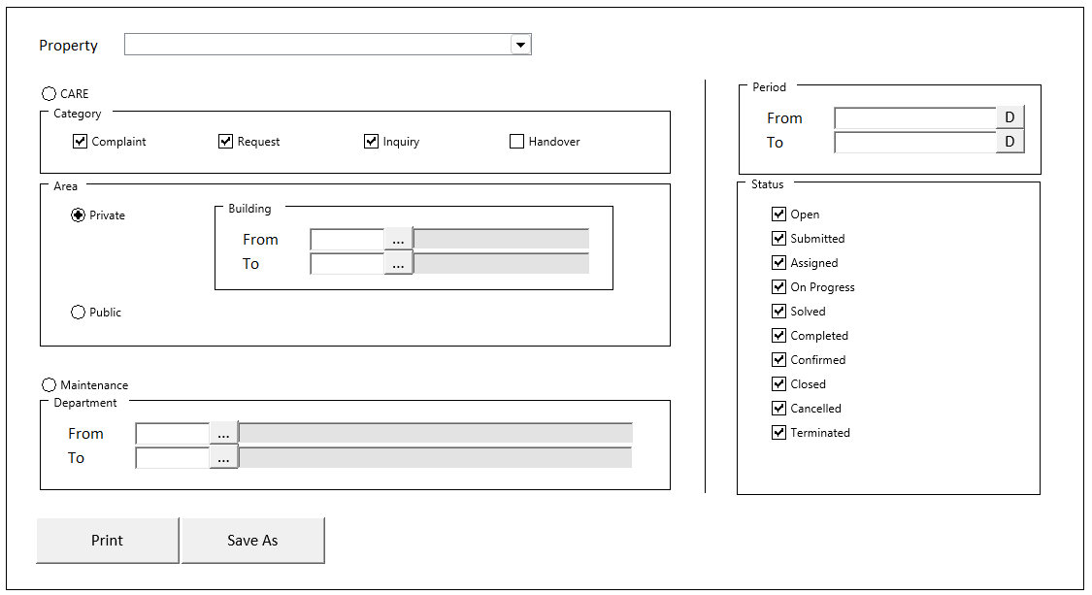

### BUTTON DEFINITION

|  |  |  |
| --- | --- | --- |
| **Button Name** | **Action** | **Enabled** |
| Print | Jalankan PRINT PROCESS |  |
| Save As | Jalankan PRINT PROCESS |  |

### ROLES

|  |  |
| --- | --- |
|  | **Test** |
| * User yg punya akses ke program |  |

### INITIAL PROCESS

|  |  |
| --- | --- |
|  | **Test** |
| * Set VAR_REPORT_TYPE (as array of object) with VAR_CODE and VAR_NAME.   + Set VAR_CODE = ‘M’, ‘C’   + Set VAR_NAME = Maintenance, CARE * Set VAR_SELECTED_ REPORT_TYPE = ‘C’ * **Get Default Param**   Jalankan RSP_PM_GET_REPORT_DEFAULT_PARAM dengan parameter, simpan hasil ke VAR_DEFAULT_PARAM   * + VAR_COMPANY_ID   + VAR_SELECTED_PROPERTY.CPROPERTY_ID   + VAR_USER_ID * **Get Area**   Jalankan RSP_GS_GET_GSB_CODE_LIST dengan parameter, simpan hasil ke VAR_AREA   * + ‘BIMASAKTI’   + VAR_COMPANY_ID   + ‘_BS_AREA’   + VAR_LANG_ID * Set VAR_SELECTED_AREA= ‘01’ |  |

### DISPLAY PROCESS

#### FIELD DEFINITION

|  |  |  |  |
| --- | --- | --- | --- |
| **Name** | **Field** | **Type** | **Validation** |
| Property | CPROPERTY_ID | Combobox, Required  Isi combobox dengan RSP_GS_GET_PROPERTY_LIST dengan parameter   * VAR_COMPANY_ID * VAR_USER_ID   Set ValueField = CPROPERTY_ID  Set TextField = CPROPERTY_NAME  Simpan hasil ke VAR_SELECTED_PROPERTY | On Value Changed,  Go to 🡪 RESET PROCESS |
| Report Type | VAR_SELECTED_REPORT_TYPE | RadioButton, Required  Isi radiobutton dengan VAR_REPORT_TYPE  Set ValueField = VAR_CODE  Set TextField = VAR_NAME  Simpan hasil ke VAR_SELECTED_REPORT_TYPE |  |
| **Category Group Box**  **[START]** |  |  |  |
| Complaint | LCOMPLAINT | Checkbox, Disabled | Enabled on,  VAR_SELECTED_REPORT_TYPE = ‘C’  IF VAR_SELECTED_REPORT_TYPE = ‘C’, TRUE  Else FALSE |
| Request | LREQUEST | Checkbox, Disabled | Enabled on,  VAR_SELECTED_REPORT_TYPE = ‘C’  IF VAR_SELECTED_REPORT_TYPE = ‘C’, TRUE  Else FALSE |
| Inquiry | LINQUIRY | Checkbox, Disabled | Enabled on,  VAR_SELECTED_REPORT_TYPE = ‘C’  IF VAR_SELECTED_REPORT_TYPE = ‘C’, TRUE  Else FALSE |
| Handover | LHANDOVER | Checkbox, Disabled | Enabled on,  VAR_SELECTED_REPORT_TYPE = ‘C’  Set Default Value = FALSE |
| **Category Group Box**  **[END]** |  |  |  |
| **Area Group Box**  **[START]** |  |  |  |
| Area | VAR_SELECTED_AREA | RadioButton  Isi radiobutton dengan VAR_AREA  Set ValueField = VAR_CODE  Set TextField = VAR_NAME  Simpan hasil ke VAR_SELECTED_AREA | On Value Changed,  IF VAR_SELECTED_AREA changed to ‘02’, then  Set CFROM_BUILDING_ID, CFROM_BUILDING_NAME, CTO_BUILDING_ID, and CTO_BUILDING_NAME = ‘’ |
| **Building Group Box**  **[START]** |  |  |  |
| Building From | CFROM_BUILDING_ID | Textbox | Enabled on  VAR_SELECTED_AREA = ‘01’  Set Default Value = VAR_DEFAULT_PARAM. CFIRST_BUILDING_ID  On Lost Focus  Go to 🡪 BUILDING LOOKUP PROCESS  On value change, update:  CFROM_BUILDING_ID, CFROM_BUILDING_NAME |
|  |  | Lookup | Enabled on  VAR_SELECTED_AREA = ‘01’  On Lookup Button clicked:  Go to 🡪 BUILDING LOOKUP PROCESS  On value change, update:  CFROM_BUILDING_ID, CFORM_BUILDING_NAME |
|  | CFROM_BUILDING_NAME | Textbox, Disabled | Set Default Value = VAR_DEFAULT_PARAM. CFIRST_BUILDING_NAME |
| Building To | CTO_BUILDING_ID | Textbox | Enabled on  VAR_SELECTED_AREA = ‘01’  Set Default Value = VAR_DEFAULT_PARAM. CLAST_BUILDING_ID  On Lost Focus  Go to 🡪 BUILDING LOOKUP PROCESS  On value change, update:  CTO_BUILDING_ID, CTO_BUILDING_NAME |
|  |  | Lookup | Enabled on  VAR_SELECTED_AREA = ‘01’  On Lookup Button clicked:  Go to 🡪 BUILDING LOOKUP PROCESS  On value change, update:  CTO_BUILDING_ID, CTO_BUILDING_NAME |
|  | CTO_BUILDING_NAME | Textbox, Disabled | Set Default Value = VAR_DEFAULT_PARAM. CLAST_BUILDING_NAME |
| **Building Group Box**  **[END]** |  |  |  |
| **Area Group Box**  **[START]** |  |  |  |
| **Department Group Box**  **[START]** |  |  |  |
| Department From | CFROM_DEPT_CODE | Textbox | Enabled on  VAR_SELECTED_REPORT_TYPE = ‘02’  Set Default Value = VAR_DEFAULT_PARAM. CFIRST_DEPT_CODE  On Lost Focus  Go to 🡪 DEPARTMENT LOOKUP PROCESS  On Lookup Process Successful, update:  CFROM_DEPT_CODE, CFROM_DEPT_NAME |
|  |  | Lookup | Enabled on  VAR_SELECTED_REPORT_TYPE = ‘02’  On Lookup Button clicked:  Go to 🡪 DEPARTMENT LOOKUP PROCESS  On Lookup Process Successful, update:  CFROM_DEPT_CODE, CFROM_DEPT_NAME |
|  | CFROM_DEPT_NAME | Textbox, Disabled | Set Default Value = VAR_DEFAULT_PARAM. CFIRST_DEPT_NAME |
| Department To | CTO_DEPT_CODE | Textbox | Enabled on  VAR_SELECTED_REPORT_TYPE = ‘02’  Set Default Value = VAR_DEFAULT_PARAM. CLAST_DEPT_CODE  On Lost Focus  Go to 🡪 DEPARTMENT LOOKUP PROCESS  On Lookup Process Successful, update:  CTO_DEPT_CODE, CTO_DEPT_NAME |
|  |  | Lookup | Enabled on  VAR_SELECTED_REPORT_TYPE = ‘02’  On Lookup Button clicked:  Go to 🡪 DEPARTMENT LOOKUP PROCESS  On Lookup Process Successful, update:  CTO_DEPT_CODE, CTO_DEPT_NAME |
|  | CTO_DEPT_NAME | Textbox, Disabled | Set Default Value = VAR_DEFAULT_PARAM. CLAST_DEPT_NAME |
| **Department Group Box**  **[END]** |  |  |  |
| **Period Group Box**  **[START]** |  |  |  |
| Period From | DFROM_PERIOD | DatePicker, Required | Set Default Value = Today |
| Period To | DTO_PERIOD | DatePicker, Required | Set Default Value = Today |
| **Period Group Box**  **[END]** |  |  |  |
| **Status Group Box**  **[START]** |  |  |  |
| Status | LSUBMITTED  Display: Submitted | Checkbox | Set Default Value = TRUE |
|  | LRECEIVED  Display: Received | Checkbox | Set Default Value = TRUE |
|  | LASSIGNED  Display: Assigned | Checkbox | Set Default Value = TRUE |
|  | LON_PROGRESS  Display: On Progress | Checkbox | Set Default Value = TRUE |
|  | LSOLVED  Display: Solved | Checkbox | Set Default Value = TRUE |
|  | LCOMPLETED  Display: Completed | Checkbox | Set Default Value = TRUE |
|  | LCONFIRMED  Display: Confirmed | Checkbox | Set Default Value = TRUE |
|  | LCLOSED  Display: Closed | Checkbox | Set Default Value = TRUE |
|  | LCANCELLED  Display: Cancelled | Checkbox | Set Default Value = TRUE |
|  | LTERMINATED  Display: Terminated | Checkbox | Set Default Value = TRUE |
| **Status Group Box**  **[END]** |  |  |  |

### BUILDING LOOKUP PROCESS

#### ON LOST FOCUS

##### PARAMETER

|  |  |
| --- | --- |
| **Parameter Name** | **Description** |
| CCOMPANY_ID | VAR_COMPANY_ID |
| CPROPERTY_ID | VAR_SELECTED_PROPERTY.CPROPERTY_ID |
| CUSER_ID | VAR_USER_ID |
| CSEARCH_TEXT | Building Id field’s value |

##### ACTION

|  |
| --- |
|  |
| * Run **GSL02200 – Building Lookup** dengan parameter:   + CCOMPANY_ID   + CPROPERTY_ID   + CUSER_ID   + CSEARCH_TEXT * Set Display Process   IF from **Building From Id** field  CFROM_BUILDING_ID = LOOKUP_RETURN_VALUE.CBUILDING_ID  CFROM_BUILDING_NAME = LOOKUP_RETURN_VALUE.CBUILDING_NAME  IF from **Building To Id** field  CTO_BUILDING_ID = LOOKUP_RETURN_VALUE.CBUILDING_ID  CTO_BUILDING_NAME = LOOKUP_RETURN_VALUE.CBUILDING_NAME |
|  |

#### BEFORE OPEN LOOKUP

##### PARAMETER

|  |  |
| --- | --- |
| **Parameter Name** | **Description** |
| CCOMPANY_ID | VAR_COMPANY_ID |
| CPROPERTY_ID | VAR_SELECTED_PROPERTY.CPROPERTY_ID |
| CUSER_ID | VAR_USER_ID |

##### ACTION

|  |
| --- |
|  |
| * Run **GSL02200 – Building Lookup** dengan parameter:   + CCOMPANY_ID   + CPROPERTY_ID   + CUSER_ID |
|  |

#### AFTER OPEN LOOKUP

##### CANCEL PROCESS

###### ACTION

|  |
| --- |
|  |
| * Close this POPUP |
|  |

##### LOOKUP SELECT DATA PROCESS

###### ACTION

|  |
| --- |
|  |
| * Close lookup * Set Display Process   IF from **Building From Id** field  CFROM_BUILDING_ID = LOOKUP_RETURN_VALUE.CBUILDING_ID  CFROM_BUILDING_NAME = LOOKUP_RETURN_VALUE.CBUILDING_NAME  IF from **Building To Id** field  CTO_BUILDING_ID = LOOKUP_RETURN_VALUE.CBUILDING_ID  CTO_BUILDING_NAME = LOOKUP_RETURN_VALUE.CBUILDING_NAME |
|  |

### DEPARTMENT LOOKUP PROCESS

#### ON LOST FOCUS

##### PARAMETER

|  |  |
| --- | --- |
| **Parameter Name** | **Description** |
| CCOMPANY_ID | VAR_COMPANY_ID |
| CUSER_ID | VAR_USER_ID |
| CSEARCH_TEXT | Building Id field’s value |

##### ACTION

|  |
| --- |
|  |
| * Run **GSL00700 – Building Lookup** dengan parameter:   + CCOMPANY_ID   + CUSER_ID   + CSEARCH_TEXT * Set Display Process   IF from **Dept From Code** field  CFROM_DEPT_CODE = LOOKUP_RETURN_VALUE.CDEPT_CODE  CFROM_DEPT_NAME = LOOKUP_RETURN_VALUE.CDEPT_NAME  IF from **Dept To Code** field  CTO_DEPT_CODE = LOOKUP_RETURN_VALUE.CDEPT_CODE  CTO_DEPT_NAME = LOOKUP_RETURN_VALUE.CDEPT_NAME |
|  |

#### BEFORE OPEN LOOKUP

##### PARAMETER

|  |  |
| --- | --- |
| **Parameter Name** | **Description** |
| CCOMPANY_ID | VAR_COMPANY_ID |
| CUSER_ID | VAR_USER_ID |

##### ACTION

|  |
| --- |
|  |
| * Run **GSL00700 – Building Lookup** dengan parameter:   + CCOMPANY_ID   + CUSER_ID |
|  |

#### AFTER OPEN LOOKUP

##### CANCEL PROCESS

###### ACTION

|  |
| --- |
|  |
| * Close this POPUP |
|  |

##### LOOKUP SELECT DATA PROCESS

###### ACTION

|  |
| --- |
|  |
| * Close lookup * Set Display Process   IF from **Dept From Code** field  CFROM_DEPT_CODE = LOOKUP_RETURN_VALUE.CDEPT_CODE  CFROM_DEPT_NAME = LOOKUP_RETURN_VALUE.CDEPT_NAME  IF from **Dept To Code** field  CTO_DEPT_CODE = LOOKUP_RETURN_VALUE.CDEPT_CODE  CTO_DEPT_NAME = LOOKUP_RETURN_VALUE.CDEPT_NAME |

### PRINT PROCESS

#### REPORT LAYOUT

PAPER SIZE: A4 LANDSCAPE  
REPORT TYPE: MAINTENANCE

##### INITIAL VERSION

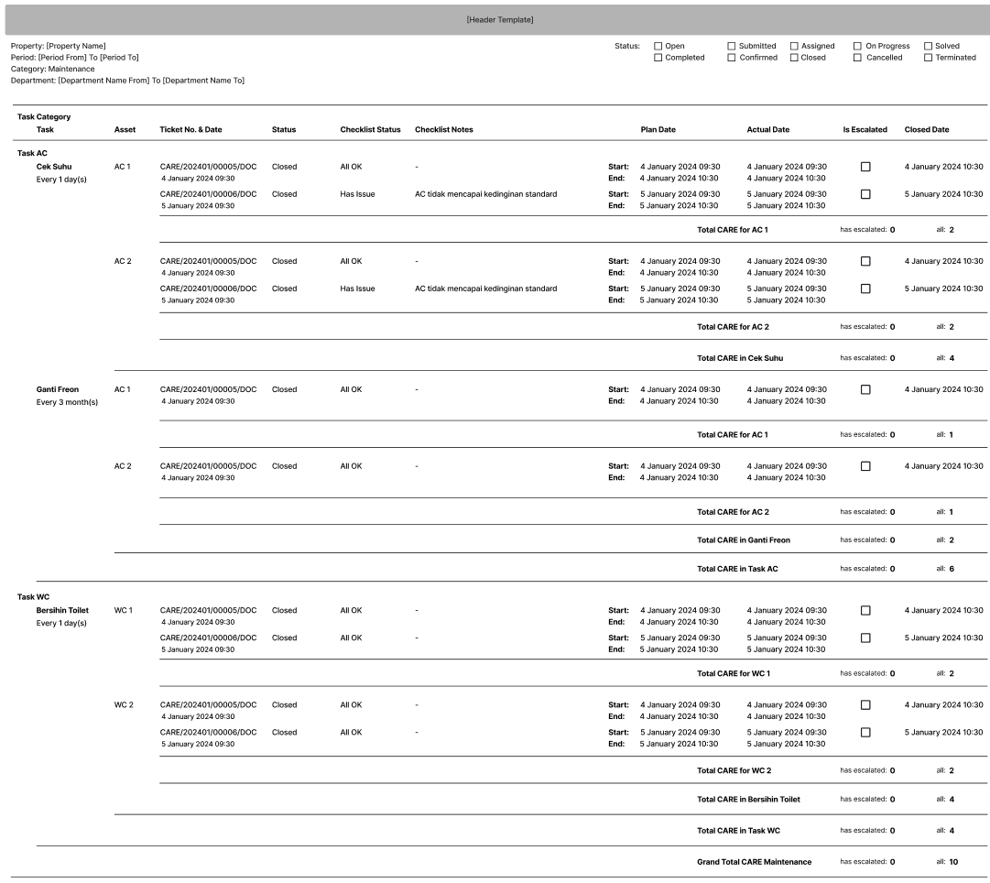

PAPER SIZE: A4 LANDSCAPE  
REPORT TYPE: CARE (PRIVATE)

##### INITIAL VERSION

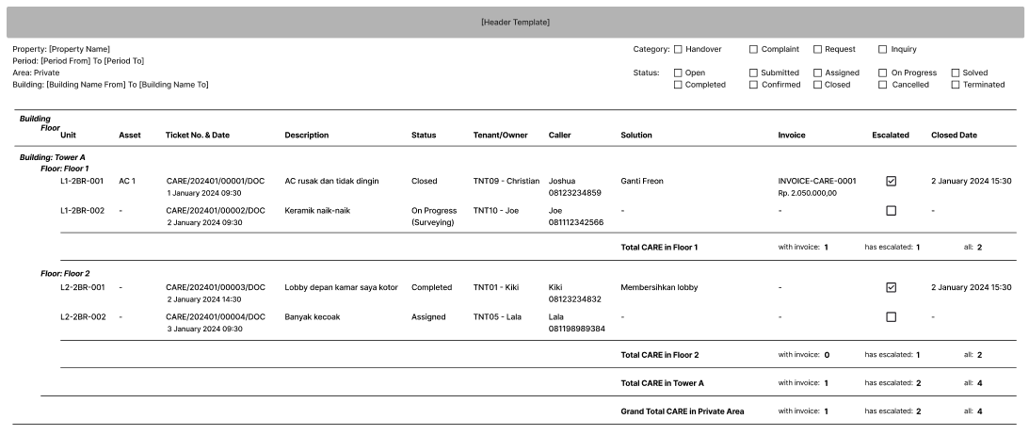

PAPER SIZE: A4 LANDSCAPE  
REPORT TYPE: CARE (PUBLIC)

##### INITIAL VERSION

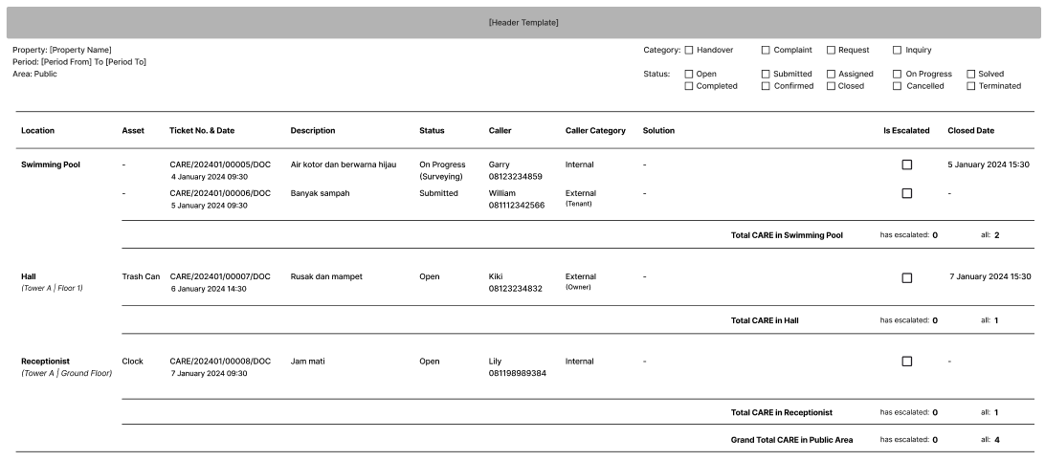

#### REPORT DEFINITION (MAINTENANCE)

|  |  |  |  |
| --- | --- | --- | --- |
| **Section** | **Name** | **Field** | **Validation** |
| **MAINTENANCE** |  |  | **VAR_REPORT_TYPE = ‘M’** |
| HEADER | Property | VAR_SELECTED_PROPERTY | Format: “Property Name”  Ex. “Harco Mas” |
|  | Period | DFROM_PERIOD, DTO_PERIOD | IF DTO_PERIOD <> DFROM_PERIOD  Format: “Period From to Period To”  ELSE  Format: “Period”  Ex.1  Selected From: “1 March 2024”  Selected To: “1 April 2024”  Display: “1 March 2024 To 1 April 2024”  Ex.2  Selected Form: “1 March 2024”  Selected To: “1 March 2024”  Display: “1 March 2024” |
|  | Category | VAR_REPORT_TYPE.VAR_NAME |  |
|  | Status | LSUBMITTED  LRECEIVED  LASSIGNED  LON_PROGRESS  LSOLVED  LCOMPLETED  LCONFIRMED  LCLOSED  LCANCELLED  LTERMINATED | IF Status = TRUE, then show checkbox with checked value  Else, show checkbox with unchecked value |
|  |  |  |  |
| REPORT GROUP |  | LMAINTENANCE = 1 | Hidden |
| GROUP BY TASK CATEGORY | Task Category | CTASK_CTG_CODE | “CTASK_CTG_NAME” |
| GROUP BY TASK | Task | CTASK_CODE | “CTASK_NAME” |
| IDURATION_TIME, CDURATION_TYPE | Format: “Every IDURATION, CDURATION_TYPE_DESCRIPTION”  Ex. 1  IDURATION_TIME = 6  CDURATION_TYPE = D  CDURATION_TYPE_DESCRIPTION = Day(s)  Display: “Every 6 Day(s)” |
| GROUP BY ASSET | Asset | CASSET_CODE |  |
| Ticket No. & Date | CCARE_TICKET_NO, DCARE_TICKET_DATE | “CCARE_TICKET_NO  DCARE_TICKET_DATE” |
| Status | CSTATUS_DESCRIPTION, CSUBSTATUS_DESCRIPTION | IF CSUBSTATUS <> “”, then  “CSTATUS_DESCRIPTION (CSUBSTATUS_DESCRIPTION)”  Else,  “CSTATUS_DESCRIPTION” |
| Checklist Status | CCHECKLIST_STATUS |  |
| Checklist Notes | CCHECKLIST_NOTES |  |
|  |  | “**Start:**  **End:** ” |
| Plan Date | DPLAN_START_DATE, DPLAN_END_DATE | “DPLAN_START_DATE  DPLAN_END_DATE” |
| Actual Date | DACTUAL_START_DATE, DACTUAL_END_DATE | “DACTUAL_START_DATE  DACTUAL_END_DATE” |
| Is Escalated | LESCALATED | IF LESCALATED = TRUE, then show checkbox with checked value  Else, show checkbox with unchecked value |
| Closed Date | DCLOSED_DATE |  |
| TOTAL BY ASSET |  |  | “**Total CARE for CASSET_NAME**” |
|  |  | “has escalated: [SUM OF LESCALATED = TRUE]” |
|  |  | “all: [SUM OF TOTAL CARE BY ASSET]” |
| TOTAL BY TASK |  |  | “**Total CARE in CTASK_NAME**” |
|  |  | “has escalated: [SUM OF LESCALATED = TRUE]” |
|  |  | “all: [SUM OF TOTAL CARE BY TASK]” |
| TOTAL BY TASK CATEGORY |  |  | “**Total CARE in CTASK_CTG_NAME**” |
|  |  | “has escalated: [SUM OF LESCALATED = TRUE]” |
|  |  | “all: [SUM OF TOTAL CARE BY TASK CATEGORY]” |
| GRAND TOTAL |  |  | “**Grand Total CARE Maintenance**” |
|  |  | “has escalated: [SUM OF LESCALATED = TRUE]” |
|  |  | “all: [SUM OF TOTAL CARE]” |

#### REPORT DEFINITION (CARE – PRIVATE)

|  |  |  |  |
| --- | --- | --- | --- |
| **Section** | **Name** | **Field** | **Validation** |
| **CARE (PRIVATE)** |  |  | **VAR_REPORT_TYPE = ‘C’ and**  **VAR_AREA = ‘01’** |
| HEADER | Property | VAR_SELECTED_PROPERTY | Format: “Property Name”  Ex. “Harco Mas” |
|  | Period | DFROM_PERIOD, DTO_PERIOD | IF DTO_PERIOD <> DFROM_PERIOD  Format: “Period From to Period To”  ELSE  Format: “Period”  Ex.1  Selected From: “1 March 2024”  Selected To: “1 April 2024”  Display: “1 March 2024 To 1 April 2024”  Ex.2  Selected Form: “1 March 2024”  Selected To: “1 March 2024”  Display: “1 March 2024” |
|  | Area | VAR_AREA.VAR_NAME |  |
|  | Building | CFROM_BUILDING_NAME  CTO_BUILDING_NAME | IF CTO_BUILDING_ID <> NULL and CTO_BUILDING_ID <> CFROM_BUILDING_ID  Format: “Building Name From To Building Name To”  ELSE  Format: “Building Name From”  Ex. 1  Selected From: TW-1 – Tower A  Selected To: TW-2 – Tower B  Display: “Tower A to Tower B”  Ex.2  Selected From: TW-1 – Tower A  Selected To: ‘’  Display: “Tower A” |
|  | Category | LHANDOVER  LCOMPLAINT  LREQUEST  LINQUIRY | IF Status = TRUE, then show checkbox with checked value  Else, show checkbox with unchecked value |
|  | Status | LSUBMITTED  LRECEIVED  LASSIGNED  LON_PROGRESS  LSOLVED  LCOMPLETED  LCONFIRMED  LCLOSED  LCANCELLED  LTERMINATED | IF Status = TRUE, then show checkbox with checked value  Else, show checkbox with unchecked value |
|  |  |  |  |
| REPORT GROUP |  | LMAINTENANCE = 0 | Hidden |
|  |  | LPRIVATE = 1 | Hidden |
| GROUP BY BUILDING | Building | CBUILDING_ID | “**Building: CBUILDING_NAME**” |
| GROUP BY FLOOR | Floor | CFLOOR_ID | “**Floor: CFLOOR_NAME**” |
| GROUP BY UNIT | Unit | CUNIT_LOCATION_ID |  |
|  | Asset | CASSET_CODE |  |
|  | Ticket No. & Date | CCARE_TICKET_NO, DCARE_TICKET_DATE | “CCARE_TICKET_NO  DCARE_TICKET_DATE” |
|  | Description | CCARE_DESCRIPTION |  |
|  | Status | CSTATUS_DESCRIPTION, CSUBSTATUS_DESCRIPTION | IF CSUBSTATUS <> “”, then  “CSTATUS_DESCRIPTION  (CSUBSTATUS_DESCRIPTION)”  Else,  “CSTATUS_DESCRIPTION” |
|  | Tenant/Owner | CTENANT_OWNER_ID | “CTENANT_OWNER_ID – CTENANT_OWNER_NAME” |
|  | Caller | CCALLER_NAME, CCALLER_PHONE | “CCALLER_NAME  CCALLER_PHONE” |
|  | Solution | CSOLUTION |  |
|  | Invoice | CINVOICE_REF_NO, CCURRENCY_SYMBOL, NTOTAL_AMOUNT | “CINVOICE_REF_NO  CCURRENCY_SYMBOL NTOTAL_AMOUNT” |
|  | Is Escalated | LESCALATED | IF LESCALATED = TRUE, then show checkbox with checked value  Else, show checkbox with unchecked value |
|  | Closed Date | DCLOSED_DATE |  |
| TOTAL BY FLOOR |  |  | “**Total CARE in CFLOOR_NAME**” |
|  |  | “with invoice: [SUM OF CREF_NO <> “-“]” |
|  |  | “has escalated: [SUM OF LESCALATED = TRUE]” |
|  |  | “all: [SUM OF TOTAL CARE BY FLOOR]” |
| TOTAL BY BUILDING |  |  | “**Total CARE in CBUILDING_NAME**” |
|  |  | “with invoice: [SUM OF CREF_NO <> “-“]” |
|  |  | “has escalated: [SUM OF LESCALATED = TRUE]” |
|  |  | “all: [SUM OF TOTAL CARE BY BUILDING]” |
| GRAND TOTAL |  |  | “**Grand Total CARE in Private Area**” |
|  |  | “with invoice: [SUM OF CREF_NO <> “-“]” |
|  |  | “has escalated: [SUM OF LESCALATED = TRUE]” |
|  |  | “all: [SUM OF TOTAL CARE]” |

#### REPORT DEFINITION (CARE – PUBLIC)

|  |  |  |  |
| --- | --- | --- | --- |
| **Section** | **Name** | **Field** | **Validation** |
| **CARE (PRIVATE)** |  |  | **VAR_REPORT_TYPE = ‘C’ and**  **VAR_AREA = ‘01’** |
| HEADER | Property | VAR_SELECTED_PROPERTY | Format: “Property Name”  Ex. “Harco Mas” |
|  | Period | DFROM_PERIOD, DTO_PERIOD | IF DTO_PERIOD <> DFROM_PERIOD  Format: “Period From to Period To”  ELSE  Format: “Period”  Ex.1  Selected From: “1 March 2024”  Selected To: “1 April 2024”  Display: “1 March 2024 To 1 April 2024”  Ex.2  Selected Form: “1 March 2024”  Selected To: “1 March 2024”  Display: “1 March 2024” |
|  | Area | VAR_AREA.VAR_NAME |  |
|  | Category | LHANDOVER  LCOMPLAINT  LREQUEST  LINQUIRY | IF Status = TRUE, then show checkbox with checked value  Else, show checkbox with unchecked value |
|  | Status | LSUBMITTED  LRECEIVED  LASSIGNED  LON_PROGRESS  LSOLVED  LCOMPLETED  LCONFIRMED  LCLOSED  LCANCELLED  LTERMINATED | IF Status = TRUE, then show checkbox with checked value  Else, show checkbox with unchecked value |
|  |  |  |  |
| REPORT GROUP |  | LMAINTENANCE = 0 | Hidden |
|  |  | LPRIVATE = 0 | Hidden |
| GROUP BY LOCATION | Location | CUNIT_LOCATION_ID, CBUILDING_ID, CFLOOR_ID | “**CUNIT_LOCATION_NAME**  (*CBUILDING_ID | CFLOOR_ID)”* |
|  | Asset | CASSET_CODE |  |
|  | Ticket No. & Date | CCARE_TICKET_NO, DCARE_TICKET_DATE | “CCARE_TICKET_NO  DCARE_TICKET_DATE” |
|  | Description | CCARE_DESCRIPTION |  |
|  | Status | CSTATUS_DESCRIPTION, CSUBSTATUS_DESCRIPTION | IF CSUBSTATUS <> “”, then  “CSTATUS_DESCRIPTION  (CSUBSTATUS_DESCRIPTION)”  Else,  “CSTATUS_DESCRIPTION” |
|  | Caller | CCALLER_NAME, CCALLER_PHONE | “CCALLER_NAME  CCALLER_PHONE” |
|  | Caller Category | CCALLER_CATEGORY, CTENANT_OR_OWNER | IF CCALLER_CATEGORY = ‘01’, then  “CCALLER_CATEGORY_DESCRIPTION”  Else,  “CCALLER_CATEGORY_DESCRIPTION  (CTENANT_OR_OWNER)” |
|  | Solution | CSOLUTION |  |
|  | Is Escalated | LESCALATED | IF LESCALATED = TRUE, then show checkbox with checked value  Else, show checkbox with unchecked value |
|  | Closed Date | DCLOSED_DATE |  |
| TOTAL BY LOCATION |  |  | “**Total CARE in CUNIT_LOCATION_NAME**” |
|  |  | “has escalated: [SUM OF LESCALATED = TRUE]” |
|  |  | “all: [SUM OF TOTAL CARE BY LOCATION]” |
| GRAND TOTAL |  |  | “**Grand Total CARE in Public Area**” |
|  |  | “has escalated: [SUM OF LESCALATED = TRUE]” |
|  |  | “all: [SUM OF TOTAL CARE]” |

#### VALIDATION

|  |  |  |
| --- | --- | --- |
| **Field** | **Condition** | **Validation Message** |
| Category | If VAR_REPORT_TYPE = ‘C’ dan  LCOMPLAINT = FALSE, dan  LREQUEST = FALSE, dan  LINQUIRY = FALSE, dan  LHANDOVER = FALSE | Please select Category! |
| Building From | IF VAR_REPORT_TYPE = ‘C’ dan VAR_AREA = ‘01’, and CFROM_BUILDING_ID is Empty | Please select Building From! |
| Building To | IF VAR_REPORT_TYPE = ‘C’ dan VAR_AREA = ‘01’, and CTO_BUILDING_ID is Empty | Please select Building To! |
| Department From | IF VAR_REPORT_TYPE = ‘M’ dan  CFROM_DEPT_CODE is Empty | Please select Department From! |
| Department To | IF VAR_REPORT_TYPE = ‘C’ dan  CTO_DEPT_CODE is Empty | Please select Department To! |
| Period From | Empty | Please fill Period From! |
| Period To | Empty | Please fill Period To! |
| Period From, Period To | If Period From > Period To | Period From cannot be after Period To! |
| Status | All is unchecked | Please check at least one status! |

#### ACTION

|  |
| --- |
|  |
| * Validate (See VALIDATION table)   IF Success, jalankan **Get Report Data**   * Set VAR_CATEGORY_ARRAY = []   + IF LHANDOVER = TRUE, VAR_CATEGORY_ARRAY add ‘02’   + IF LCOMPLAINT = TRUE, VAR_CATEGORY_ARRAY add ‘03’   + IF LREQUEST = TRUE, VAR_CATEGORY_ARRAY add ‘04’   + IF LINQUIRY = TRUE, VAR_CATEGORY_ARRAY add ‘05’ * Set VAR_CATEGORY = Join VAR_CATEGORY_ARRAY with ‘,’ * Set VAR_STATUS_ARRAY = []   + IF LSUBMITTED = TRUE, VAR_STATUS_ARRAY add ‘01’   + IF LRECEIVED = TRUE, VAR_STATUS_ARRAY add ‘02’   + IF LASSIGNED = TRUE, VAR_STATUS_ARRAY add ‘03’   + IF LON_PROGRESS = TRUE, VAR_STATUS_ARRAY add ‘04’   + IF LSOLVED = TRUE, VAR_STATUS_ARRAY add ‘05’   + IF LCOMPLETED = TRUE, VAR_STATUS_ARRAY add ‘06’   + IF LCONFIRMED = TRUE, VAR_STATUS_ARRAY add ‘07’   + IF LCLOSED = TRUE, VAR_STATUS_ARRAY add ‘08’   + IF LCANCELLED = TRUE, VAR_STATUS_ARRAY add ‘09’   + IF LTERMINATED = TRUE, VAR_STATUS_ARRAY add ‘10’ * Set VAR_STATUS = Join VAR_STATUS_ARRAY with ‘,’   **BEGIN TRANSACTION**   * **Get Report Data**   Jalankan RSP_HDR00200_GET_REPORT dengan parameter,  @CCOMPANY_ID = VAR_COMPANY_ID  @CPROPERTY_ID = VAR_SELECTED_PROPERTY.CPROPERTY_ID  @CREPORT_TYPE = VAR_SELECTED_REPORT_TYPE.VAR_CODE  @CAREA = VAR_SELECTED_AREA.VAR_CODE (IF CREPORT_TYPE = ‘C’ then VAR_SELECTED_AREA.VAR_CODE, else ‘’)  @CFROM_BUILDING_ID = CFROM_BUILDING_ID (IF CREPORT_TYPE = ‘C’ AND CAREA = ‘01’ then CFROM_BUILDING_ID, else ‘’)  @CTO_BUILDING_ID = CTO_BUILDING_ID (IF CREPORT_TYPE = ‘C’ AND CAREA = ‘01’ then CTO_BUILDING_ID, else ‘’)  @CFROM_DEPT_CODE = CFROM_DEPT_CODE (IF CREPORT_TYPE = ‘M’ then CFROM_DEPT_CODE, else ‘’)  @CTO_DEPT_CODE = CTO_DEPT_CODE (IF CREPORT_TYPE = ‘M’ then CTO_DEPT_CODE, else ‘’)  @CFROM_PERIOD = DFROM_PERIOD (YYYYMMDD)  @CTO_PERIOD = DTO_PERIOD (YYYYMMDD)  @CCATEGORY = VAR_CATEGORY (IF CREPORT_TYPE = ‘C’ then VAR_CATEGORY, else ‘’)  @CSTATUS = VAR_STATUS  @CUSER_ID = VAR_USER_ID  @CLANG_ID = VAR_LANGUAGE_ID  Ex. Maintenance  EXEC RSP_HDR00200_GET_REPORT  ‘RCD’  , ‘ASHMD’  , ‘M’  , ‘’  , ‘’  , ‘’  , ‘ACC’  , ‘FIN’  , ‘20241001’  , ‘20241130’  , ‘’  , ’01,02,03,04’  , ‘NS’  , ‘EN’  Ex. CARE (Private)  EXEC RSP_HDR00200_GET_REPORT  ‘RCD’  , ‘ASHMD’  , ‘C’  , ‘01’  , ‘TW-A’  , ‘TW-C’  , ‘’  , ‘’  , ‘20241001’  , ‘20241130’  , ’03,04,05’  , ’01,02,03,04’  , ‘NS’  , ‘EN’  Ex. CARE (Public)  EXEC RSP_HDR00200_GET_REPORT  ‘RCD’  , ‘ASHMD’  , ‘C’  , ‘02’  , ‘’  , ‘’  , ‘’  , ‘’  , ‘20241001’  , ‘20241130’  , ’03,04,05’  , ’01,02,03,04’  , ‘NS’  , ‘EN’  **COMMIT TRANSACTION** |
| * Proses:   + ‘Print’ 🡪 Display Report PDF File in new tab   + ‘Save As 🡪 Prompt download as Excel |

# CR LIST

|  |  |  |
| --- | --- | --- |
| **CR** | **Description** | **Notes** |
|  |  |  |